CSA1503: Cloud computing and big data analytics
Eperiment 3: Create a simple cloud software application for Car Booking Reservation System using any Cloud Service Provider to demonstrate SaaS include the necessary fields such as search for cabs, from, to, rental, out station, Package type, hours/Days etc.
Input:
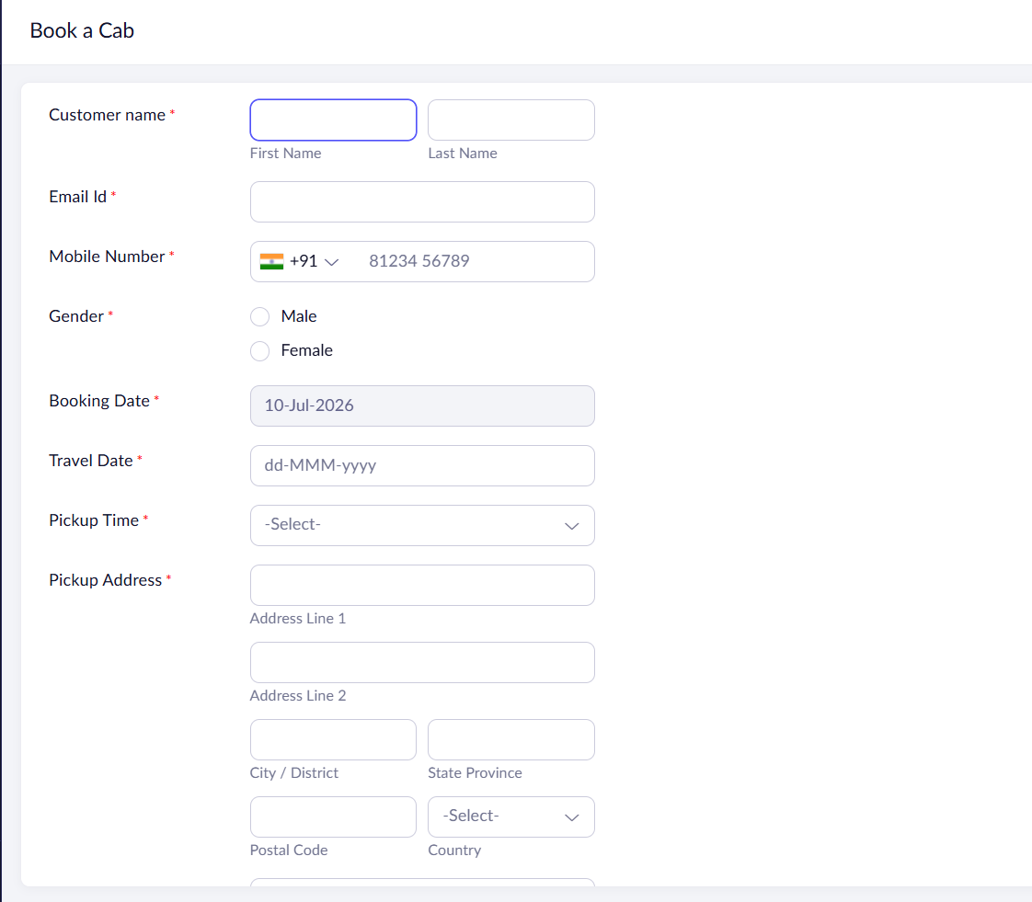

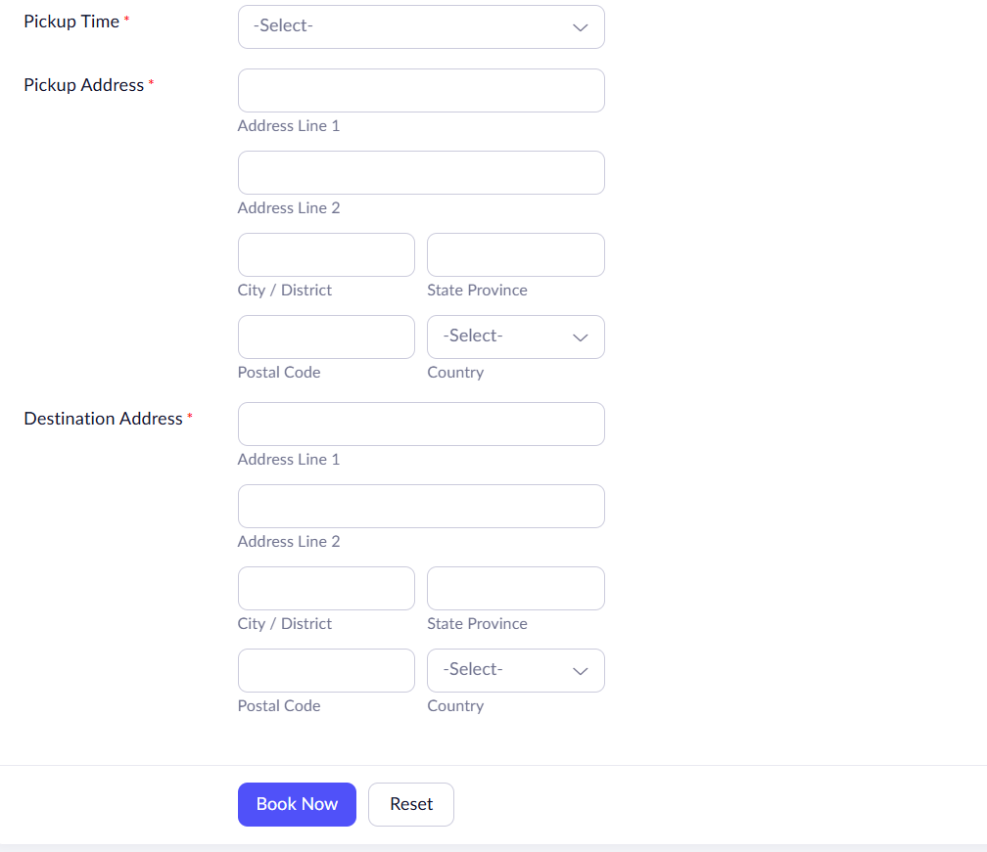
Output:
